Voice Controlled Obstacle Avoiding Car

*By*

Sanath Singavarapu with Reg No:188

Musale Krushna Pavan with Reg No:150



*Bachelor Thesis submitted to*

Indian Institute of Information Technology Kalyani

*for the partial fulfillment of the degree of*

**Bachelor of Technology**

**in**

**Computer Science and Engineering/Information Technology**

**May 2018**

Certificate

This is to certify that the thesis entitled “Voice Controlled Obstacle Avoiding Car” being submitted by Sanath Singavarapu and Musale Krushna Pavan, an undergraduate student, Reg. No: 188 and 150, in the Department of Computer Science and Information Engineering, Indian Institute of Information Technology Kalyani, West Bengal 741235, India, for the award of Bachelor of Technology in Computer Science and Information Engineering /Information Technology is an original research work carried by him under my supervision and guidance. The thesis has fulfilled all the requirements as per the regulations of Indian Institute of Information Technology Kalyani and in my opinion, has reached the standards needed for submission. The work, techniques and the results presented have not been submitted to any other University or Institute for the award of any other degree or diploma.

Dr. Dalia Nandi Das,

Faculty

Electronics Department

Declaration

I hereby declare that the work being presented in this thesis entitled, “Voice Controlled Obstacle Avoiding Car”, submitted to Indian Institute of Information Technology Kalyani in partial fulfillment for the award of the degree of **Bachelor of Technology** in Computer Science and Engineering during the period from July, 2017 to May, 2018 under the supervision of Dr. Dalia Nandi Das, Department of Computer Science and Engineering, Indian Institute of Information Technology Kalyani, West Bengal 741235, India, does not contain any classified information.

Name of the Candidate: Sanath Singavarapu, Musale Krushna Pavan.

Reg No/Roll No:188,150.

Name of the Department: Computer Science and Engineering.

Institute Name: Indian Institute of Information Technology Kalyani

This is to certify that the above statement made by the candidate is correct to the best of my knowledge.

..................................

Dr. Dalia Nandi Das,

Faculty

Electronics Department

Place: Kalyani

Date:

Acknowledgments

First of all, I would like to take this opportunity to thank my supervisor ……………………………

Name of the Candidate

Reg No/Roll No

Name of the Department

Institute Name

Place:

Date:

Table of Contents:

1. Introduction

2. Components Used

-Arduino Uno

-Motor Driver

-Ultrasonic Sensor

-Bluetooth Module

4. Circuit Diagram

5. The theory behind the work

6. Applications and Future Work

7. References

Introduction

The main motive of the project is to develop a car that can be controlled using voice commands over Bluetooth module and an external software while it itself avoid obstacles using ultrasonic sensor.

We connect the Bluetooth module with the mobile app. Once done, the commands which we give through the mobile get sent to the Arduino via the module. We accept character by character from the serial buffer sent by the app and combine them to form a string.

We then compare it to the command. If it matches, the command is carried out. For example, when the string we receive is "Right", the bot turns right.

**Components:**

* Arduino Uno
* Breadboard
* Motors x2
* Wheels x2
* Chassis (of appropriate size)
* Voltage Regulator LM7805
* L293D
* 12V battery (power source)
* Jumper wires
* Bluetooth Module HC-05

**Arduino Uno Board**

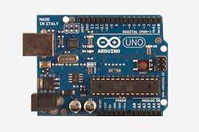

The Arduino UNO is an open-source microcontroller board based on [Microchip](https://en.wikipedia.org/wiki/Microchip_Technology) [ATmega328P](https://en.wikipedia.org/wiki/ATmega328P) microcontroller and developed by [Arduino.cc](https://en.wikipedia.org/wiki/Arduino). The board is equipped with sets of digital and analog input/output (I/O) pins that may be interfaced to various expansion boards (shields) and other circuits. The Uno also differs from all preceding boards in that it does not use the FTDI USB-to-serial driver chip. Instead, it uses the Atmega16U2 (Atmega8U2 up to version R2) programmed as a USB-to-serial converter

Motor Driver

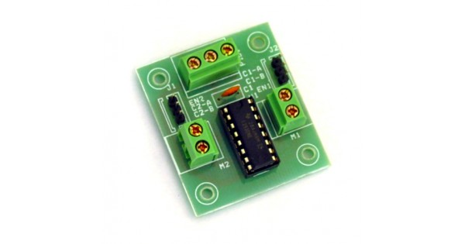

Motor Driver circuits are current amplifiers. They act as a bridge between the controller and the motor in a motor drive. Motor drivers are made from discrete components which are integrated inside an IC. The input to the motor driver IC or motor driver circuit is a low current signal. The function of the circuit is to convert the low current signal to a high current signal. This high current signal is then given to the motor. The motor can be a brushless DC motor, brushed DC motor, stepper motor, other DC motors etc.

Ultrasonic Sensor

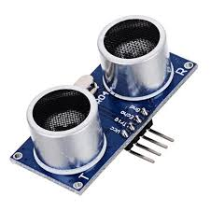

**Ultrasonic transducers** or **ultrasonic sensors** are a type of acoustic sensor divided into three broad categories: transmitters, receivers and transceivers. Transmitters convert [electrical signals](https://en.wikipedia.org/wiki/Signal_(electrical_engineering)) into [ultrasound](https://en.wikipedia.org/wiki/Ultrasound), receivers convert ultrasound into electrical signals, and transceivers can both transmit and receive ultrasound.

In a similar way to [radar](https://en.wikipedia.org/wiki/Radar) and [sonar](https://en.wikipedia.org/wiki/Sonar), ultrasonic [transducers](https://en.wikipedia.org/wiki/Transducer) are used in systems which evaluate targets by interpreting the reflected signals. For example, by measuring the time between sending a signal and receiving an echo the distance of an object can be calculated. Passive ultrasonic sensors are basically microphones that detect ultrasonic noise that is present under certain conditions.

Bluetooth Module

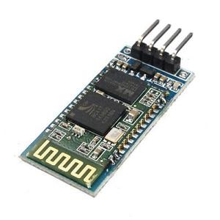

The HC-06 is a class 2 slave **Bluetooth module** designed for transparent wireless serial communication. ... When the **module** receives wireless data, it is sent out through the serial interface exactly at it is received. No user code specific to the **Bluetooth module** is needed at all in the user microcontroller program.

The HC-06 will work with supply voltage of 3.6VDC to 6VDC, however, the logic level of RXD pin is 3.3V and is not 5V tolerant. A [Logic Level Converter](http://www.sgbotic.com/index.php?dispatch=products.view&product_id=1613)is recommended to protect the sensor if connect it to a 5V device(e.g. Arduino Uno and Mega).

Circuit Diagram

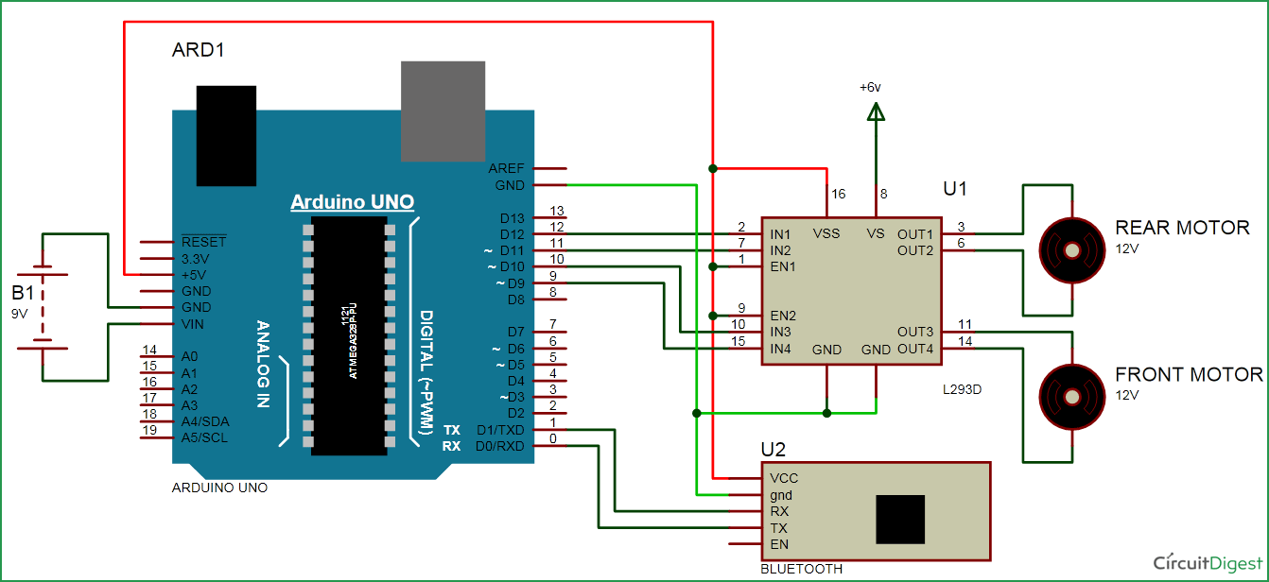

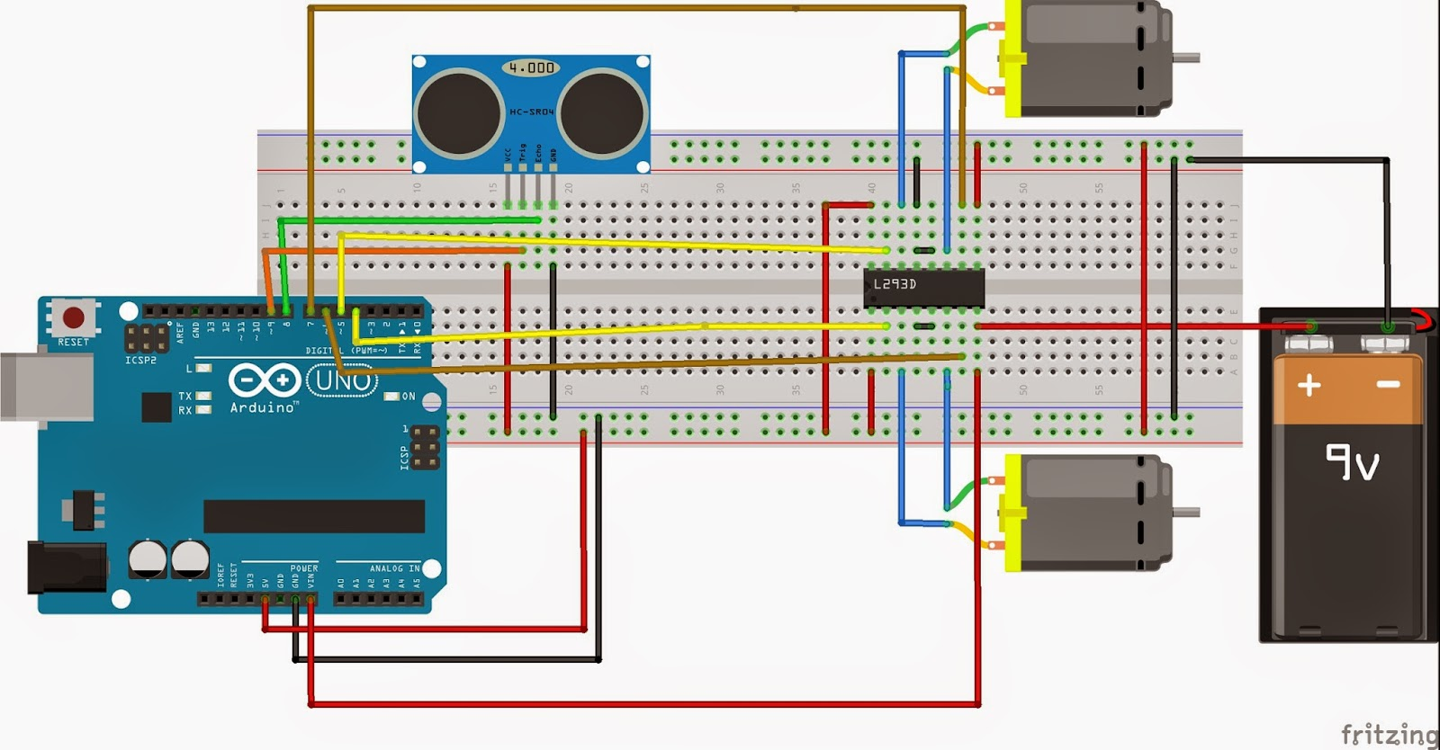

The theory behind the innovation

Arduino uno is the brains of the project for mine. You can use NANO/MEGA/MICRO. And I would use Bluetooth connectivity feature for controlling the car with smartphone.

So I have provided the circuit in the Fritzing File. Download Fritzing and open it and see the file. Connect as shown in the diagram. Use the voltage divider as given with 2.2k and 4.7k. Now the yellow wires (as per that fritzing file) represent the 4 output that would control the motor driver. Those 4 logic levels actually are the inputs of the motor driver and the motor driver uses that logic levels to move as per the logic levels are fed. And the Arduino controls that......means that it enables the driver to move both motors forward or backward or reverse or move right or left or just stop. This is accomplished in the code.

So see the diagrams above and then connect the motor driver inputs. Then connect the motors at the output with a couple of screws and fix the wheels. I have connected my L293 driver as per its connection. Check your own driver, search over the net and datasheets and connect as per required.

Now the voice feature actually works with the Bluetooth. There is an app on called "BT Voice Control for Arduino" Link-<https://amr-voice.en.aptoide.com/>. Download and install it on android phone and pair with HC05. If you are connecting for 1st time, pair it beforehand with 1234 or 0000 as pass. If it does not pair, try again.

Now after you speak on the app after a couple of seconds it returns what you just said on your mobile screen. It actually uses the Google Voice. So now what you said is transmitted over the Bluetooth. Upload the test code given on theUno.remove RX TX lines while uploading. After uploading reinsert again. The HC05 accepts that data using the Serial.read() function and you can see what you just said on the serial monitor using Serial.print. So you can check the working of the app there. Speak anything on the app and see the serial monitor. If you say forward it will show as *forward# and work on even with other respective commands to move.

Now upload the full Arduino code that controls the car. Now while uploading it, make sure you have disconnected the RX TX lines. It won't be uploaded otherwise. After uploading connect them again. Now connect a 12V power source. You have to just speak up the word on the app to make the car move.

Now connect the Ultrasonic Sensor as given in the circuit diagram. The ultrasonic sensor sends an echo Wave and receives the trigger wave whenever it is collided with an obstacle. On receiving a trigger pin the car gets stopped at the position where it is present. Make sure that the ultrasonic sensor is working by Serial Monitor

Advantages and Future Improvement

The voice controlled car has its own advantage that it is simply being controlled by voice commands over Bluetooth module which has a range of 50 to 70 meters. The commands that are programmed are quite simple to Use. ‘Forward’ to move forward. ’Left’ to steer the vehicle left and move forward. ‘Right’ to steer the vehicle right and move forward. ‘Reverse’ to move in reverse direction. ‘Stop’ to stop the vehicle right at its position. The car even self detect obstacles and stops whenever it detects an obstacle. The car uses an ultrasonic sensor to detect so. Even the cost of all the sensor used in this car are quite cheaper and most widely available.

As planned the car will be implemented with most advanced sensors for efficient working.

References:

1. <https://en.wikipedia.org/wiki/Arduino_Uno>
2. Getting Started with Arduino – Book by Massimo Banzi
3. <https://en.wikipedia.org/wiki/Bluetooth>
4. <https://en.wikipedia.org/wiki/Ultrasonic_transducer>